­­­­­GLOBAL HISTORY 1

**DOCUMENT 1A**

|  |
| --- |
| The first successful efforts to control the flow of water were made in Mesopotamia and Egypt, where the remains of the prehistoric irrigation works still exist. In ancient Egypt, the construction of canals was a major endeavor of the pharaohs and their servants, beginning in Scorpio’s time. One of the first duties of provincial governors was the digging and repair of canals, which were used to flood large tracts of land while the Nile was flowing high. The land was checkerboarded with small basins, defined by a system of dikes. Problems regarding the uncertainty of the flow of the Nile were recognized. During very high flows, the dikes were washed away and villages flooded, drowning thousands. During low flows, the land did not receive water, and no crops could grow. In many places where fields were too high to receive water from the canals, water was drawn from the canals or the Nile directly by a swape or a shaduf. These consisted of a bucket on the end of a cord that hung from the long end of a pivoted boom, counterweighted at the short end. The building of canals continued in Egypt throughout the centuries.… |

Source: Larry W. Mays, “Irrigation Systems, Ancient,” Water Encyclopedia online (adapted)

**DOCUMENT 1B**

|  |
| --- |
| https://blastfferomthepast.files.wordpress.com/2018/04/img_0676.jpg?w=739 |

**DOCUMENT 2**

|  |
| --- |
| I request that you establish water conservation offices in each district and staff them with people who are experienced in the ways of water. There should be one high official and one deputy with just enough workers to meet the need. For the area on both sides of each river select one person as chief hydraulic engineer. Order inspections of the waterways, the walls of the cities and their suburbs, the dikes and rivers, canals and pools, and government buildings and cottages, and supply enough workers to those who are to carry out the repair work in each district. |

Source: Han government official, writing to local officials concerning flood prevention, early second century B.C.E.

**DOCUMENT 3**

|  |
| --- |
| From planning to completion, building an aqueduct was an extremely costly enterprise, a project for which many Roman cities proudly raised funds. Evidence shows that money often came from both public and private sources.  Sometimes aqueducts were paid for by leading citizens. The work was usually carried out as part of their political role. For example, as aedile and consul, Augustus’ son-in-law Agrippa used his own mines to produce the lead pipes that lined the Aqua Julia and Aqua Virgo. From Augustus’ time onward, emperors regularly made donations to the upkeep of this expensive infrastructure.  Among the very few sources to shed light on how aqueducts were built is a Roman funerary monument found at the city of Bejaïa in Algeria. This commemorates the life of one Nonius Datus, an engineer, and recounts the difficulties he encountered in carrying out his work. The long text, written after the aqueduct’s completion around A.D. 152, describes how the city’s inhabitants lobbied for an improved water supply. The process was not as speedy as might have been hoped. Datus planned the aqueduct’s route in around 138. However, the work was not completed until 152, following a series of setbacks, which the monument describes in detail. Most crucially, the teams of workmen who started excavating the two sides of the tunnel did not meet where they were supposed to. On another occasion, bandits attacked the site and Datus escaped by the skin of his teeth, naked, battered, and bruised.  The Roman administration expended huge efforts not just in conveying water, but in maintaining its purity. A large group of specialized workers known as *aquarii,* ensured the aqueducts’ proper operation and cleanliness. These technicians carried out repairs and systematically cleaned the channels to prevent blockages and maintain a decent water quality. The channel along which the water flowed was always kept covered and tanks called *piscinae limariae* were placed along the route into which impurities were regularly decanted…  To such a practical people as the Romans, aqueducts were a source of great pride and even part of their identity. Frontinus made that clear in his treatise on these great public works. “With such an array of indispensable structures carrying so much water, compare, if you will, the idle Pyramids or the useless, though famous, works of the Greeks!” |

SOURCE: Aqueducts: Quenching Rome’s Thirst by Isabel Rodά <https://www.nationalgeographic.com/archaeology-and-history/magazine/2016/11-12/roman-aqueducts-engineering-innovation/>

**DOCUMENT 4**

***What is it about Roman concrete that keeps the Pantheon and the Colosseum still standing?***

|  |
| --- |
| The Romans started making concrete more than 2,000 years ago, but it wasn’t quite like today’s concrete. They had a different formula, which resulted in a substance that was not as strong as the modern product. Yet structures like the Pantheon and the Colosseum have survived for centuries, often with little to no maintenance. Geologists, archaeologists and engineers are studying the properties of ancient Roman concrete to solve the mystery of its longevity…  That resistance, or durability against the elements, may be due to one of the concrete’s key ingredients: volcanic ash. Modern concrete is a mix of a lime-based cement, water, sand and so-called aggregates such as fine gravel. The formula for Roman concrete also starts with limestone: builders burned it to produce quicklime and then added water to create a paste. Next they mixed in volcanic ash—usually three parts volcanic ash to one part lime, according to the writings of Vitruvius, a first-century B.C. architect and engineer. The volcanic ash reacted with the lime paste to create a durable mortar that was combined with fist-size chunks of bricks or volcanic rocks called tuff, and then packed into place to form structures like walls or vaults…  In the earliest concretes, Romans mined ash from a variety of ancient volcanic deposits. But builders got picky around the time Augustus became the first Roman emperor, in 27 B.C. At that time, Augustus initiated an extensive citywide program to repair old monuments and erect new ones, and builders exclusively used volcanic ash from a deposit called Pozzolane Rosse, an ash flow that erupted 456,000 years ago from the Alban Hills volcano, 12 miles southeast of Rome.  “Emperor Augustus was the driving force behind the systemization, standardization of mortar mixes with Pozzolane Rosse,” says Marie Jackson, a geologist and research engineer at the University of California at Berkeley. Roman builders likely favored the ash deposit because of the durability of concrete made with it, she adds. “This was the secret to concretes that were very well bonded, coherent, robust materials…”  Despite the success of Roman concrete, the use of the material disappeared along with the Roman Empire. Concrete structures were seldom built during the Middle Ages, suggesting volcanic ash wasn’t the only secret to the durability of Roman concrete, Perucchio says. “These really large projects could only be done with the appropriate bureaucracy, with the proper organization that the Roman Empire would provide.” |

SOURCE: The Secrets of Ancient Rome’s Buildings by Erin Wayman

<https://www.smithsonianmag.com/history/the-secrets-of-ancient-romes-buildings-234992/#a9tgpyAXd4lkAUjI.99>

**DOCUMENT 5A**

**On paper the Grand Canal** runs 1,100 miles, between Beijing and the southern metropolis of Hangzhou. But for nearly four decades the top half of its course—from Beijing to Jining—has been too dry for shipping. The waterway’s main commercial artery now spans the 325 miles from Jining to the Yangtze.

|  |
| --- |
| The original canal system, built by Emperor Yang of the Sui dynasty, was seen by Chinese historians as an act of brilliant madness. Ancient China’s main rivers ran west to east, and Yang wanted to break this grip of geography. He needed a way to move rice from the fertile region around the Yangtze northwest to feed his court and, crucially, his armies, which were constantly battling nomadic tribes. So the emperor’s officials press-ganged an estimated million workers, mostly farmers, into building the first section of the canal. Supervised by thousands of soldiers, the men and women were driven around the clock. Yang “inflicted intolerable sufferings,” a ninth-century poet wrote, yet these projects “provided endless benefits to the people.” Officially the work was finished in 171 days in the year 605, but in reality it took six years to complete and claimed an untold number of lives—many of them villagers who starved because there weren’t enough hands left to harvest the crops.  The canal did more than move grain—as the country’s unifying feature, it was a potent political symbol and a strategic target for invaders. In the early 1840s, when the British wanted to put a stranglehold on China during the first Opium War, they occupied Zhenjiang, at the intersection of the canal and the Yangtze, throttling the flow of grain and tax revenues to Beijing. Within weeks China surrendered.  The Grand Canal was also a cultural conduit. Emperors on visits to inspect the canal’s locks and levees observed and co-opted local ways. That’s said to be how Beijing acquired two trademarks: Peking duck, from Shandong Province, and Peking opera, from Anhui and Hubei. Theater troupes, who relied on the canal to get around, said prayers to its wharves, while poets were moved by its very presence. Writing in the eighth century, Zhang Ji describes a temple on the canal whose “ringing bell reaches my boat at midnight.” |

Source: <https://www.nationalgeographic.com/magazine/2013/05/grand-canal/>

**DOCUMENT 5B**

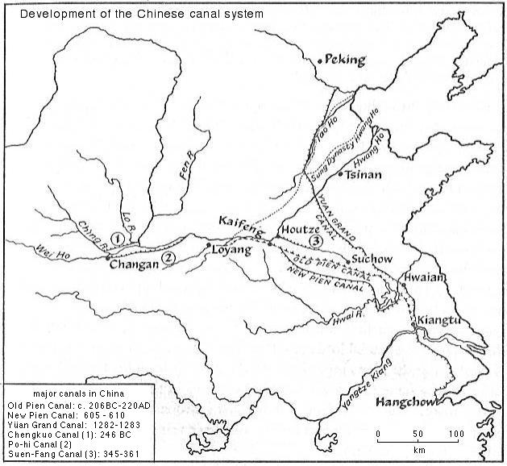

Source: Trager, T. R. (1965) *Geography of China.* University of London Press, London

<http://www.incois.gov.in/Tutor/science+society/lectures/illustrations/lecture15/canals.html>